Jahangirnagar University (JU)



**Institute of Information Technology**

**Lab Report-5**

Assembly Language

**Name:** Md. Shakil Hossain **Roll:** 2023

# Experiment 1:

To arrange three numbers in descending order.

# Algorithm:

1. Load the first digit into a register.
2. Load the second digit into another register.
3. Compare the first and second digits.
4. If the first digit is less than the second digit, swap the two digits.
5. Load the third digit into another register.
6. Compare the first digit with the third digit.
7. If the first digit is less than the third digit, swap the first and third digits.
8. Compare the second digit with the third digit.
9. If the second digit is less than the third digit, swap the second and third digits.
10. The three digits are now arranged in descending order.

# Flow Chart

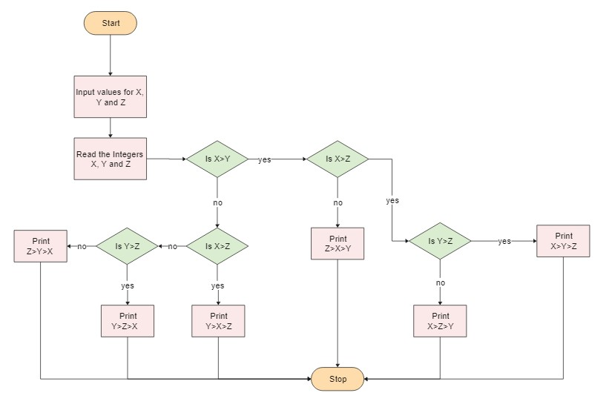

**Program Source Code:**

include 'emu8086.inc'

data segment

num1 db 0

num2 db 0

num3 db 0

data ends

code segment

assume cs:code,ds:data

start:

mov ax,data

mov ds,ax

print 'Enter First Number: '

mov ah,01h

int 21h

mov num1,al

printn ''

print 'Enter Second Number: '

mov ah,01h

int 21h

mov num2,al

printn ''

print 'Enter Third Number: '

mov ah,01h

int 21h

mov num3,al

mov al,num1

mov bl,num2

cmp al,bl

jg swap1

mov num1,bl

mov num2,al

swap1:

mov al,num2

mov bl,num3

cmp al,bl

jg swap2

mov num2,bl

mov num3,al

swap2:

mov al,num1

mov bl,num2

cmp al,bl

jg display

mov num1,bl

mov num2,al

display:

printn ''

print 'Sorted: '

mov dl,num1

mov ah,02h

int 21h

print ' '

mov dl,num2

mov ah,02h

int 21h

print ' '

mov dl,num3

mov ah,02h

int 21h

printn ''

mov ah,4ch

int 21h

code ends

end start

**Sample Input: 7 3 5**

**Sample Output: 7 5 3**

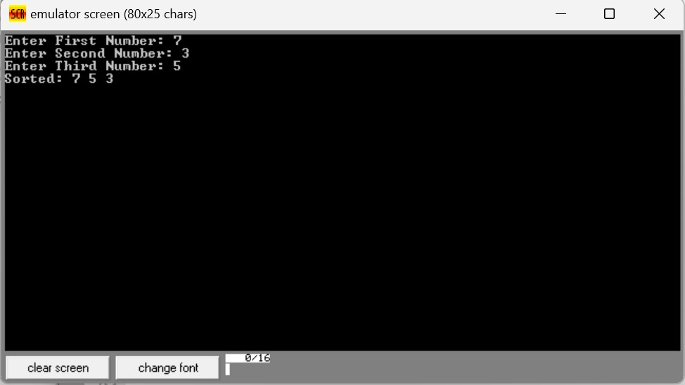

# Experiment 2:

To find the summation of series of four 8-bit numbers

# Algorithm:

1. Load the first 8-bit number into a register.
2. Load the second 8-bit number into another register.
3. Add the second number to the first number, storing the result in the first register.
4. Load the third 8-bit number into the second register.
5. Add the third number to the result in the first register, storing the result in the first register.
6. Load the fourth 8-bit number into the second register.
7. Add the fourth number to the result in the first register, storing the result in the first register.
8. Store the final result in memory.

# Flow Chart:

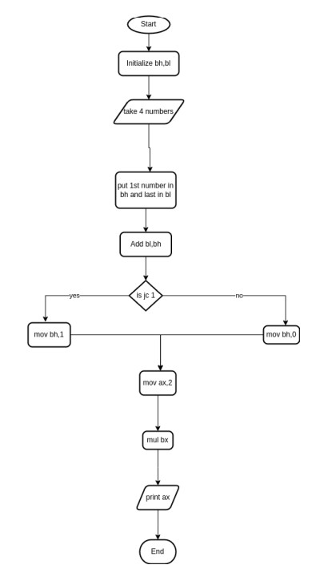

**Program Source Code:**

.model small

.stack 100h

.data

msg1 dw 'Enter 1st number of series : $'

msg2 dw 'Enter 4th number of series : $'

msg3 dw 'Summation of series : $'

nl db 0ah,0dh,'$'

.code

main proc

mov ax,@data

mov ds,ax

lea dx,msg1

mov ah,9

int 21h

mov ah,1

while:

int 21h

cmp al,0dh

je end_while

cmp al,39h

jg letter

and al,0fh

jmp shift

letter:

sub al,37h

shift:

shl bh,4

or bh,al

jmp while

end_while:

lea dx,nl

mov ah,9

int 21h

lea dx,msg2

mov ah,9

int 21h

mov ah,1

while2:

int 21h

cmp al,0dh

je end_while2

cmp al,39h

jg letter2

and al,0fh

jmp shift2

letter2:

sub al,37h

shift2:

shl bl,4

or bl,al

jmp while2

end_while2:

lea dx,nl

mov ah,9

int 21h

add bl,bh

jc one

jmp zero

one:

mov bh,1

jmp prnt

zero:

mov bh,0

prnt:

lea dx,msg3

mov ah,9

int 21h

mov ax,2

mul bx

mov bx,ax

mov cx,4

mov ah,2

for:

mov dl,bh

shr dl,4

shl bx,4

cmp dl,10

jge letter3

add dl,30h

int 21h

jmp end_of_loop

letter3:

add dl,55

int 21h

end_of_loop:

loop for

main endp

end main

**Sample Input:** 15 30

**Sample Output:** 008A

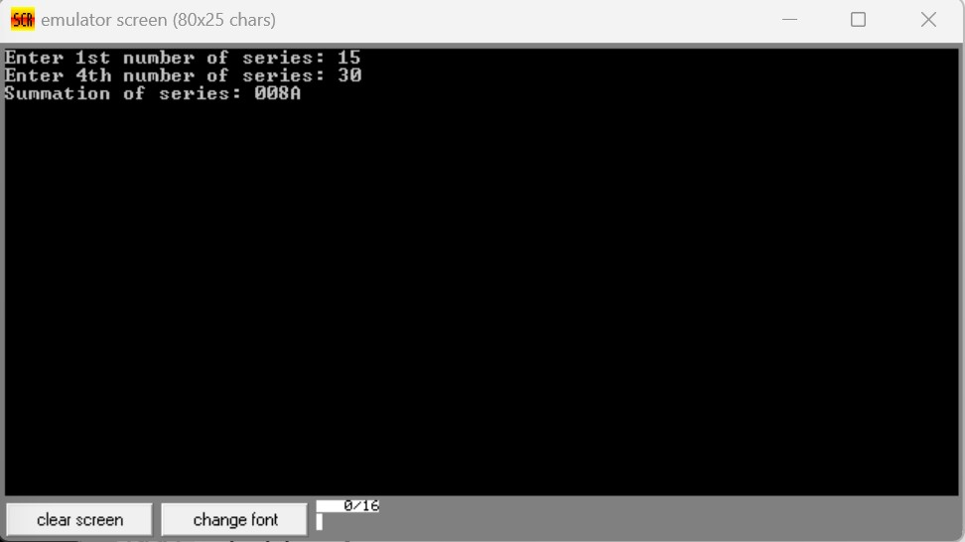

**THE END**